

**Institute of Distance and Open Learning**

Vidya Nagari, Kalina, Santacruz East – 400098.

CERTIFICATE

This is to certify that, this project report entitled **“Car rental”** is a record of work carried out by **Mr. Siddique Aminuddin Sameeuddin Aasma (Seat no-**10477**),** student of **MCA semester-II** class and is submitted to University of Mumbai, in partial fulfilment of the requirement for the award of the degree of **Master in Computer Application**. The project report has been approved.

Guide External Examiner Coordinator – M.C.A

# Approval of Project

This is to certify that the project work entitled ***“Car rental”,*** for **Master in Computer Application** submitted to University of Mumbai by ***Mr. Siddique Aminuddi Sameeuddin Aasma (Seat no-***10477***)*** a bonafide student of Institute of Distance and Open Learning, Vidyanagari,Kalina ,Santracruz East has been approved for the award of ***Master in Computer Application****.*

**Examiner 1.**

**2.**

Date:

Place:

# Declaration

I declare that this written submission represents my ideas in my own words and where other's ideas or words have been included, I have adequately cited and referenced the original sources. I also declare that I have adhered to all principles of academic honesty and integrity and have not misrepresented or fabricated or falsified any idea/data/fact/source in my submission. I understand that any violation of the above will be cause for disciplinary action by the Institute and can also evoke penal action from the sources which have thus not been properly cited or from whom proper permission has not been taken when needed.

(Signature)

Mr. Siddique Aminuddin Sameeuddin Aasma

Seat No-10477

Date:

Place:

ACKNOWLEDGMENT

After the completion of this work, words are not enough to express my feelings about all those who helped me to reach my goal; feeling above this is my indebtedness to the almighty for providing me this moment in my life.

It’s a great pleasure and moment of immense satisfaction for me to express my profound gratitude to my project guide, **Prof. Vijay Kothawade** whose constant encouragement enabled me to work enthusiastically. His perpetual motivation, patience and excellent expertise in discussion during progress of dissertation work have benefited me to an extent, which is beyond expression. His depth and breadth of knowledge of Engineering field made me realize that theoretical knowledge always help to develop efficient operational software, which is a blend of all core subjects of the field. The completion of this project would not have been possible without his encouragement, patient guidance and constant support.

I would like to thank all staff members for their valuable cooperation and permitting me to work in the computer labs.

Special thanks to my colleagues and friends for providing me useful comments, suggestions and continuous encouragement.

Finally, I thanks my family members, for their support and endurance during this

work.

**Mr. Siddique Aminuddin Sameeuddin Aasma**

(Seat No: 10477)

Contents

Approval of Project 2

Declaration 3

1 . Introduction 6

1.1 Project Definition 6

1.2 Need for system 6

1.3 Future Prospects 7

2. Analysis 8

2.1 Project Plan 8

2.1.1 Project Overview 8

2.1.2 Project Scope 8

2.1.3 Project Phases 8

**2.2 Requirement Analysis** 9

2.2.1 Functional Requirements 9

2.2.2 Non-functional Requirements 9

2.2.3 User Requirements 9

2.2.4 System Constraints 9

3. Design 10

3.1 System Architecture 10

3.1.1 Dashboard 10

3.1.2 Car Rental Management 10

3.1.3 Landing Page Generator 10

3.2 Risk Assessment 11

4. Modeling 12

4.1 UML Diagram 12

4.2 Use Case Diagram 13

5. Methodology 14

5.1 Software Used 14

5.2 Hardware Specification 14

5.3 Programming Language 14

5.4 Platform 14

5.5 Components 14

5.6 Tools 14

5.7 Coding Style Followed 14

5.8 Methods and Procedures 14

6. Result 15

7. Testing 22

7.1 Test Plan 22

7.2 Test Cases 24

8. Conclusion 25

# 1 . Introduction

In the rapidly evolving landscape of car rental management and web development, the demand for integrated solutions that seamlessly combine car rental functionalities, user interaction, and efficient web page generation has become essential. The Car Rental Portal, a robust and innovative web-based application, is designed to address this demand by providing a comprehensive platform for listing, booking, and managing rental cars

.

## Project Definition

Introducing the Car Rental Portal, our innovative software project that seamlessly merges the functionality of a car rental management system with the creativity of a web page generator. In today's dynamic digital environment, businesses, entrepreneurs, and teams seek efficient car rental management for organizational effectiveness and a captivating online presence to engage their audience.

Our all-in-one solution aims to streamline these critical aspects, offering a comprehensive platform that empowers users to list, book, and manage rental cars with ease. Whether you are an administrator aiming to simplify car rental operations or a user in search of a user-friendly platform for booking and managing car rentals, our software project bridges the gap between operational efficiency and user convenience.

Welcome to the Car Rental Portal, ushering in a new era of car rental management, where productivity and user-friendly design converge seamlessly in one integrated platform.

## 1.2 Need for system

The Car Rental Portal project serves a critical purpose in the car rental industry by seamlessly integrating project management and web page generation. This innovative software project provides a unified solution, offering a comprehensive tool for managing car rental operations and an intuitive platform for creating visually appealing web pages.

In a fast-paced digital environment, where efficiency and creativity are paramount, the Car Rental Portal eliminates the need for separate tools. Users can effortlessly transition between organizing car rental tasks and designing captivating web pages, fostering collaboration between project managers and marketing teams.

By breaking down silos and providing a cohesive working environment, the Car Rental Portal enhances collaboration, making it easier for teams to work together on tasks and present rental cars in an engaging manner. This integration represents a new era in car rental management, where efficiency and creativity converge seamlessly, empowering users to manage tasks and impress their audience, all within a single, unified platform.

Welcome to a transformative approach to car rental management, where the Car Rental Portal redefines efficiency and creativity.

## Future Prospects

The Car Rental Portal, integrating a management tool and a landing page generator, envisions empowering small entrepreneurs to establish an online presence, drive business growth, and provide a holistic solution for efficient operations and sustained expansion

# 2. Analysis

In the analysis phase, we examine the Car Rental Portal system across various components:

## 2.1 Project Plan

### 2.1.1 Project Overview

* **Project Name:** Car Rental Portal
* **Project Duration:** 3 months

## 2.1.2 Project Scope

* **Project Management Tool:**
  + Project management
  + Task Management
  + Team Collaboration
  + Progress Tracking
* **Web Page Generator:**
  + Template customization
  + Version control for web pages (Future scope)
  + Subscription model (Future scope)

## 2.1.3 Project Phases

* **Phase 1: Planning (Week 1 - 3)**
  + Defined project scope and objectives
  + Researched tools and web page generators
  + Assigned roles to team members
* **Phase 2: Design (Week 3 - 5)**
  + Designed project interface using Figma and Canva
  + Implemented the interface
  + Determined integration points between project management tool and web page generator
* **Phase 3: Development (Week 6 - 8)**
  + Developed the system by implementing code in appropriate languages and frameworks
* **Phase 4: Deployment (Week 9 - 10)**
  + Conducted system testing, dividing the system into modules
  + Addressed and resolved issues identified during testing
* **Phase 5: Monitoring and Optimization (Week 11 - 12)**
  + Calculated system efficiency
  + Fixed errors found during testing
  + Prepared documentation for the system

The Car Rental Portal development followed a systematic approach, encompassing planning, design, development, deployment, and ongoing monitoring and optimization.

# 

## **2.2 Requirement Analysis**

In this phase, we outline the functional, non-functional, user requirements, and system constraints for the Car Rental Portal:

### 2.2.1 Functional Requirements

* User authentication and authorization
* Project management tool
* Web page generator
* UI and UX
* Notification and alerts
* Search and navigation
* Security

### 2.2.2 Non-functional Requirements

* Performance
* Reliability
* Scalability
* Availability
* Maintainability
* Documentation

### 2.2.3 User Requirements

* User Authentication and access
* Intuitive user interface
* Task management
* Web page generation
* Notification and alert
* Data security and privacy

### 2.2.4 System Constraints

* Cloudflare
* Great server VPS
* MongoDB
* Razorpay
* Postman
* Browser
* SMTP server

The Car Rental Portal is designed to meet diverse functional and non-functional requirements, ensuring user satisfaction and system robustness within the specified constraints.

# 3. Design

The design phase centers on tailoring the system to meet user requirements, with a primary focus on cultivating a user-friendly interface.

## 3.1 System Architecture

### 3.1.1 Dashboard

The Car Rental Portal dashboard offers a user-friendly interface presenting key elements for effective car rental management:

* **Total Cars Listed:** Provides an overview of the total number of cars available for rental.
* **Booking Status:** Offers real-time updates on ongoing bookings, showcasing reservations, confirmations, and completed bookings.
* **Revenue Overview:** Displays a visual representation of revenue generated through the platform, showcasing current and cumulative earnings.
* **User Engagement:** Metrics on user interactions, including new registrations, recent bookings, and testimonials.

### 3.1.2 Car Rental Management

The heart of the Car Rental Portal involves managing rental cars efficiently. This section includes functionalities such as:

* **Car Listing:** Enables users to list and manage rental cars.
* **Booking Management:** Allows users to make bookings and view booking history.
* **User Profiles:** Permits users to update their profiles and passwords.
* **Testimonials:** Facilitates the posting and viewing of user testimonials.
* **Inquiries Handling:** Manages user inquiries through the contact us page.

### 3.1.3 Landing Page Generator

The Landing Page Generator simplifies the process of creating an online presence:

* **Questionnaire:** Users answer questions related to their business and preferences.
* **Generate Website:** By clicking the "Generate Website" button, a landing page tailored to the user's responses is created seamlessly.

## 3.2 Risk Assessment

| **Risk ID** | **Description** | **Risk Level** |
| --- | --- | --- |
| R01 | Technical Risk | High |
| R02 | Scalability Risk | Medium |
| R03 | Data Breach | Low |
| R04 | Operational Risk | Medium |
| R05 | Payment Risk | Low |

Table 1: Risk Assessment

The risk assessment identifies potential challenges and assigns risk levels. Technical risk is assessed as high, scalability and operational risks as medium, and data breach and payment risks as low.

# 4. Modeling

In this we simply show our system architecture. We define our system flow by using UML diagram and Use case diagram.

## 4.1 UML Diagram

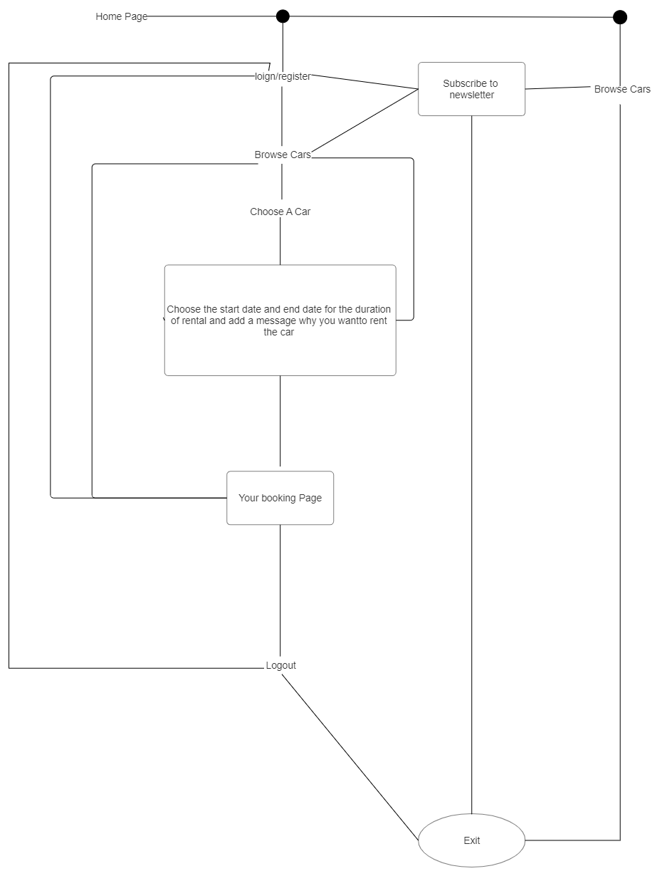

Fig 1 UML Diagram

## 4.2 Use Case Diagram

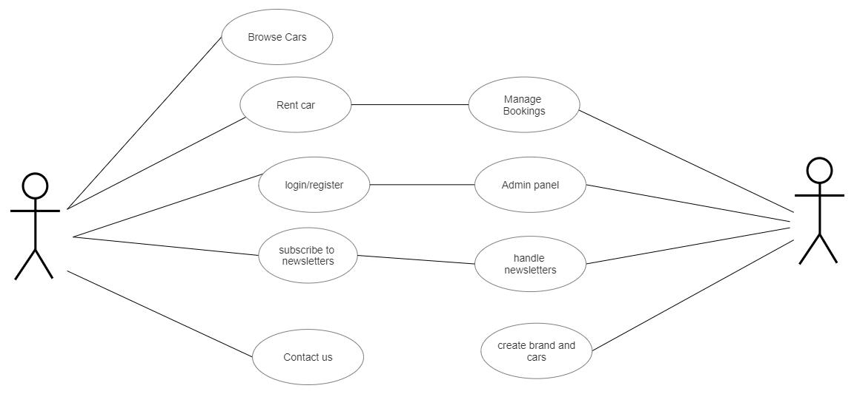

Fig 2 Use case Diagram

# 5. Methodology

In this section, we outline the methodologies, tools, and procedures employed during the development of the Car Rental Portal.

## 5.1 Software Used

* Visual Studio Code
* Chrome Web Browser

## 5.2 Hardware Specification

* Laptop
* Internet Connection

## 5.3 Programming Language

* **HTML, CSS:**
  + Utilized for designing purposes.
* **JavaScript and jQuery:**
  + Employed for frontend development.
* **PHP:**
  + Used for server-side scripting.

## 5.4 Platform

* **Web Browser:**
  + To run the web application.

## 5.5 Components

* **Server:**
  + PHP scripts running on the server.
* **Database Server:**
  + MySQL database for handling project-related data, tasks, and user information.
* **Client Devices:**
  + Any modern computing device with a web browser and JavaScript enabled.
* **Network Infrastructure:**
  + Reliable network infrastructure, including routers and switches.

## 5.6 Tools

* **Visual Studio Code:**
  + Used for overall development.
* **Web Browser:**
  + To run the web application.

## 5.7 Coding Style Followed

* HTML5
* CSS3
* JavaScript and jQuery
* PHP

## 5.8 Methods and Procedures

* **Requirement Analysis:**
  + Collaborated with stakeholders to gather system requirements, defining necessary and desirable features.
* **System Design:**
  + Developed user interface using HTML, CSS, and Bootstrap.
* **Development:**
  + Utilized PHP for server-side scripting, and JavaScript/jQuery for frontend functionality.
* **Testing:**
  + Conducted extensive testing, including unit testing for individual components and integration testing for system functionality.
* **Deployment:**
  + Rolled out the system to a controlled environment, ensuring compatibility and usability.
* **Documentation:**
  + Documented the entire development process, including code documentation and user manuals.

# 6. Result

Showcasing the Car Rental Portal's sleek UI through screenshots. From the welcoming home page to user-friendly booking processes, it exemplifies seamless design and functionality.

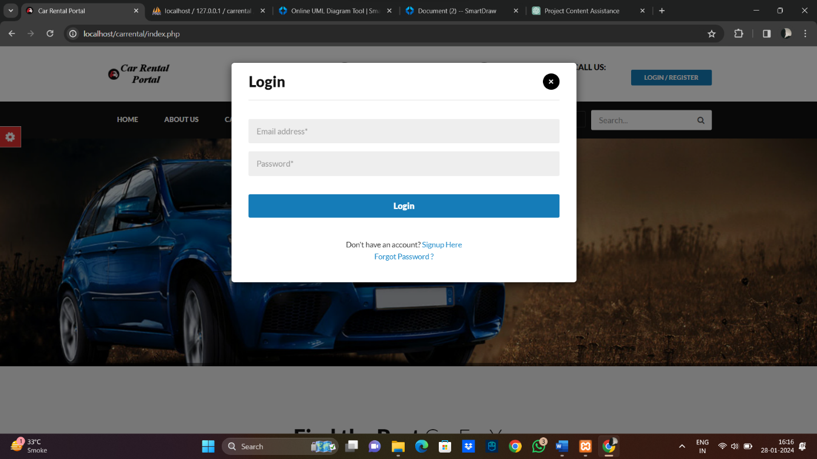

Figure 3 User Login

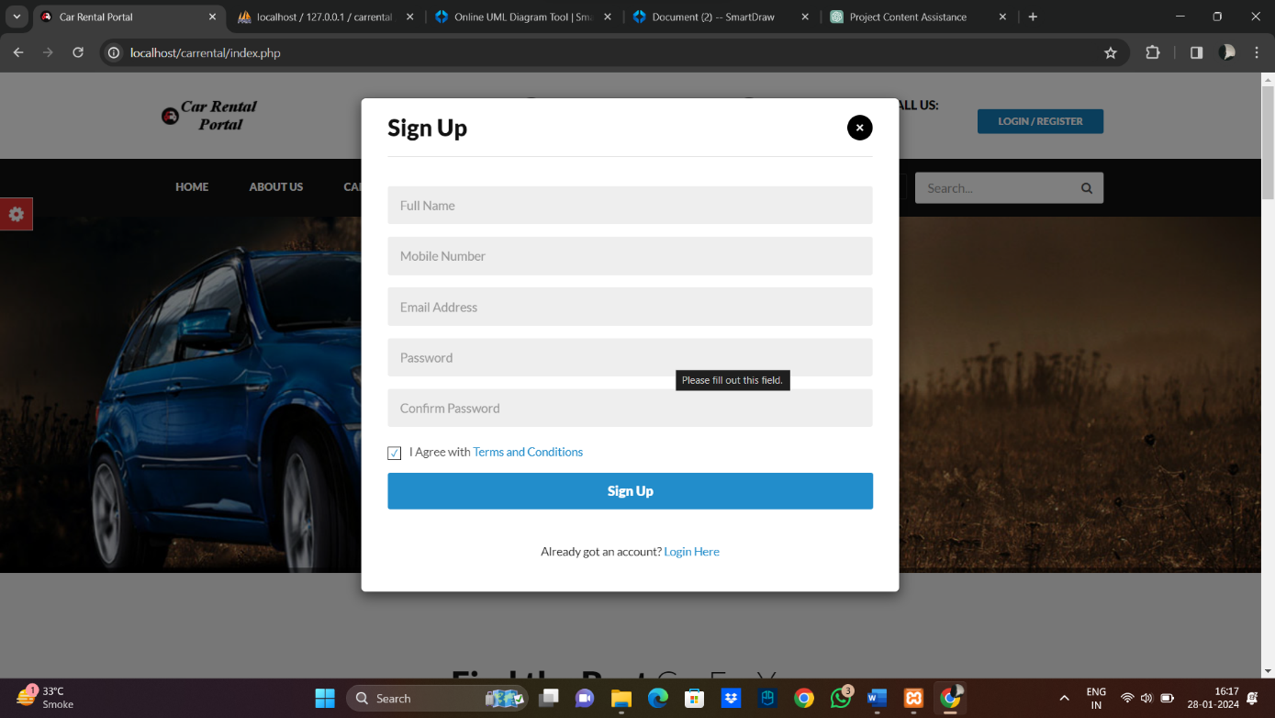

Figure 4 Register User

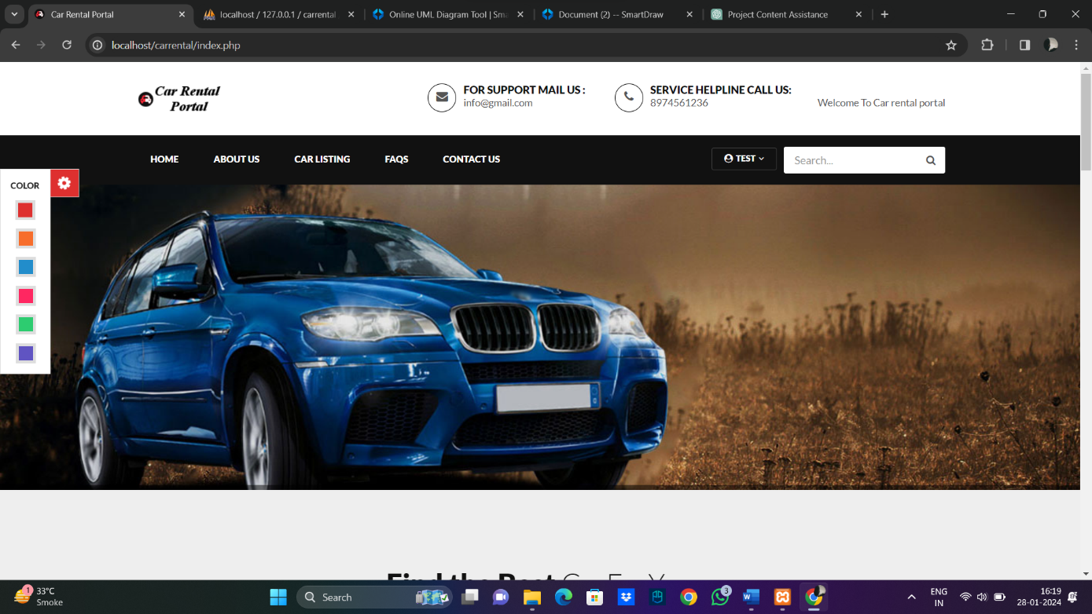

Figure 5 Homepage UI

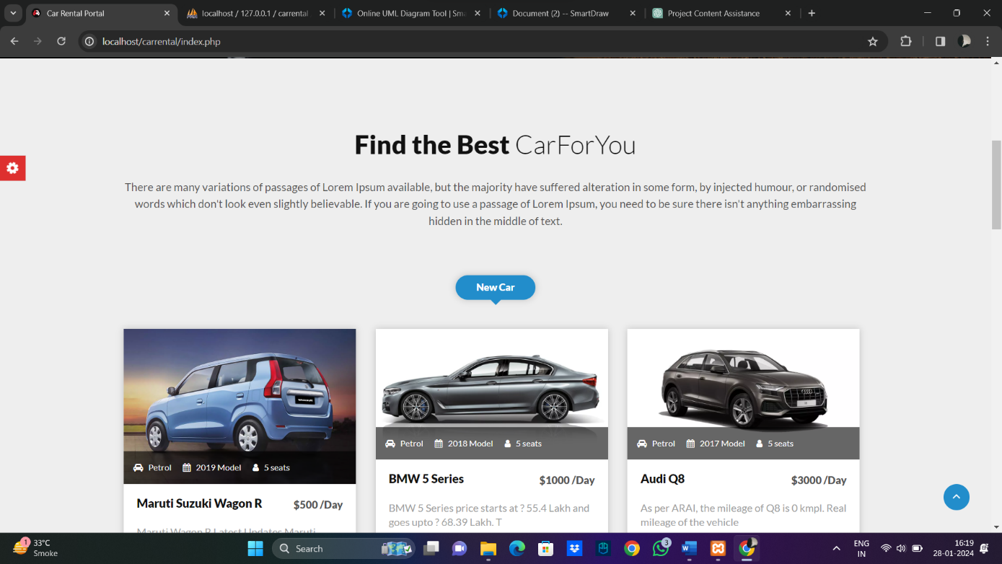

Figure 6 Cars Page

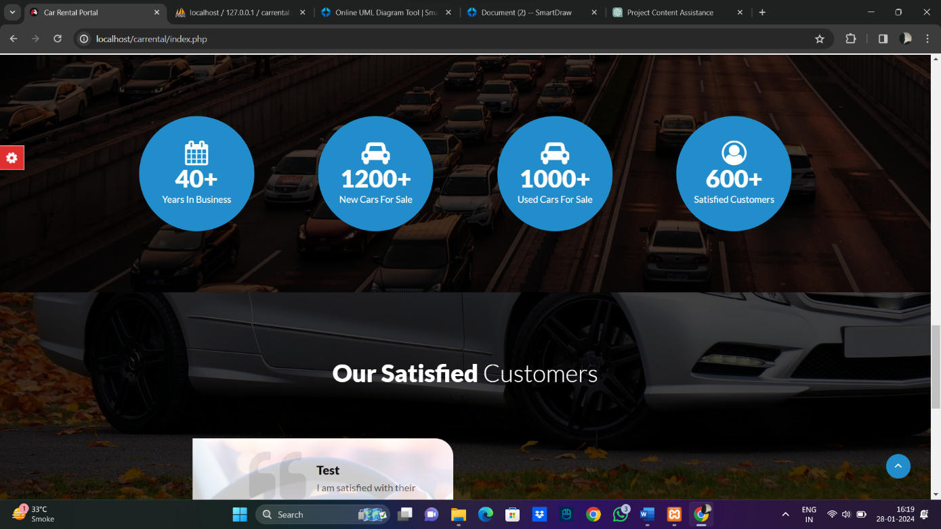

Figure 7 Rankings and number

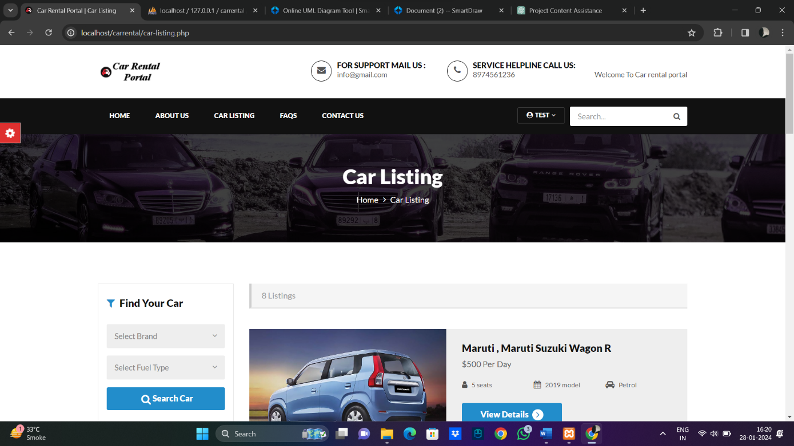

Figure 8 Car Listings

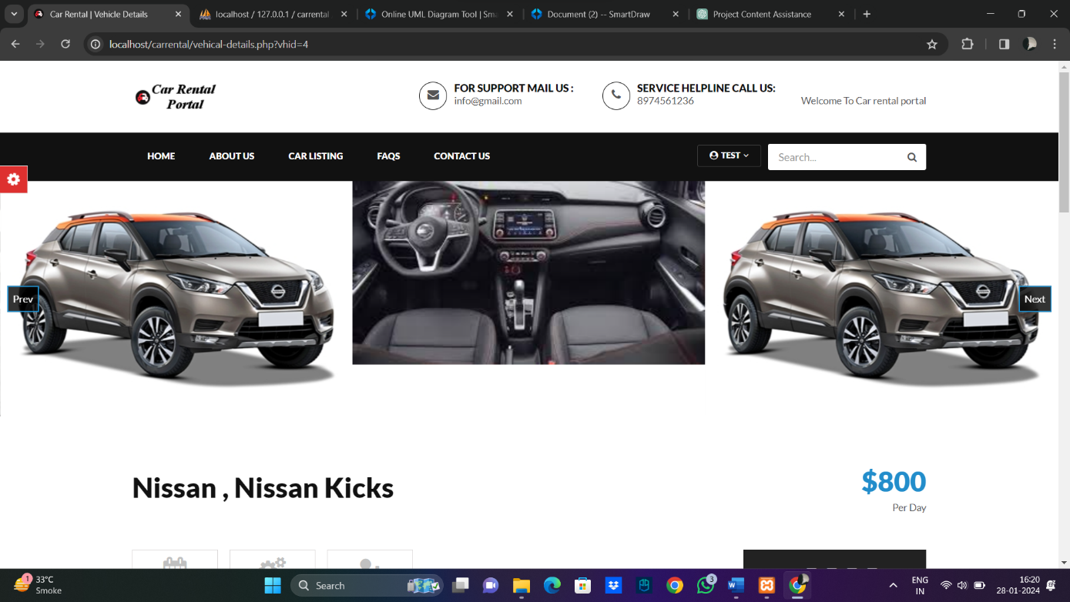

Figure 9 Single Car page 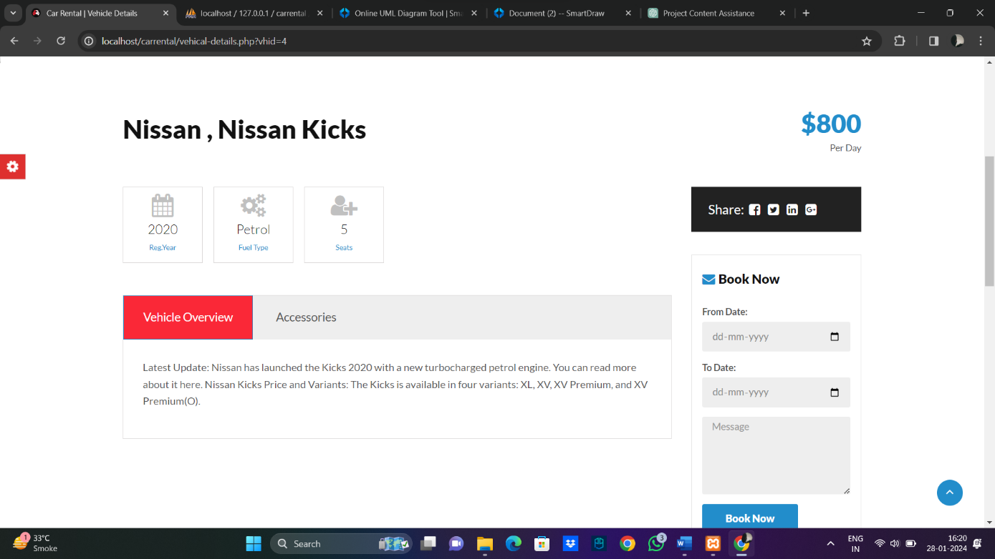

Figure 10 Car Booking Section

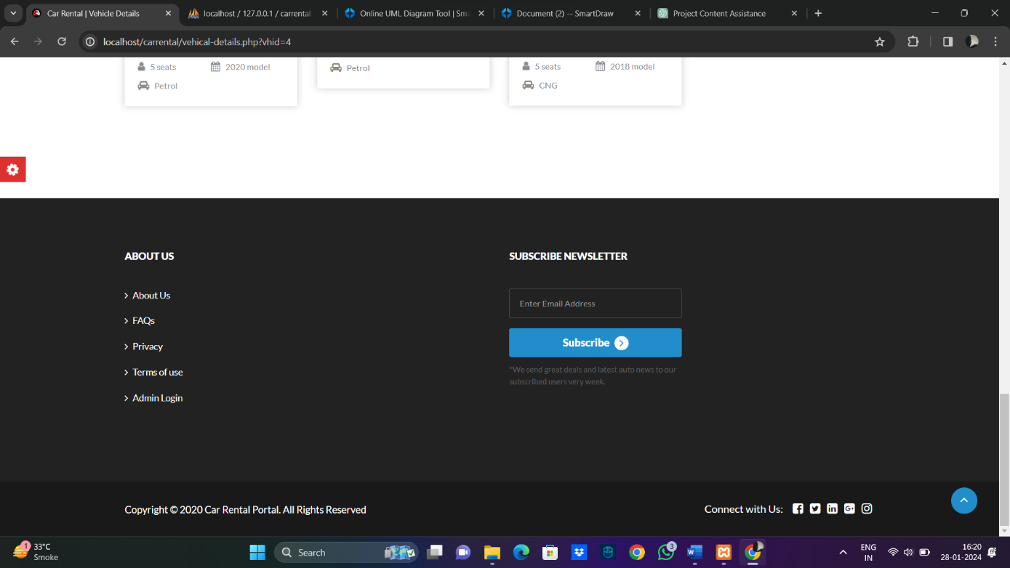

Figure 11 Newsletter section 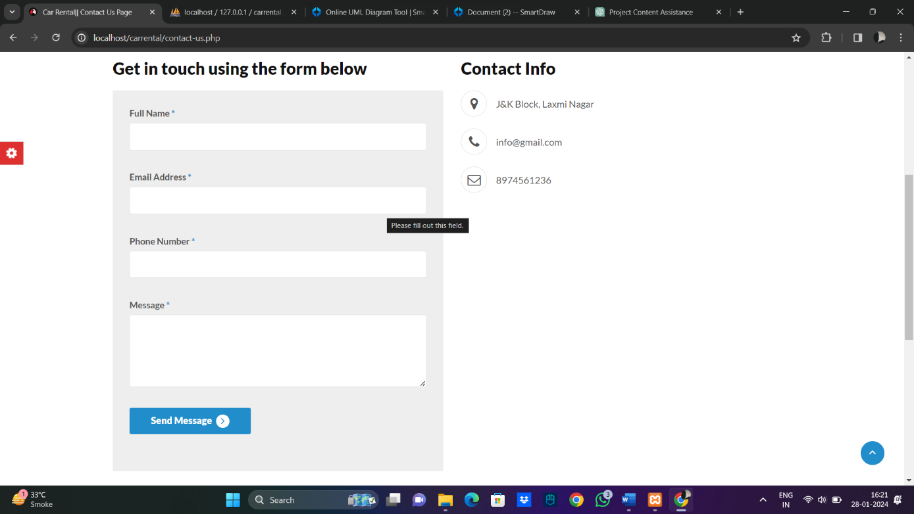

Figure 11 Get In Touch Section

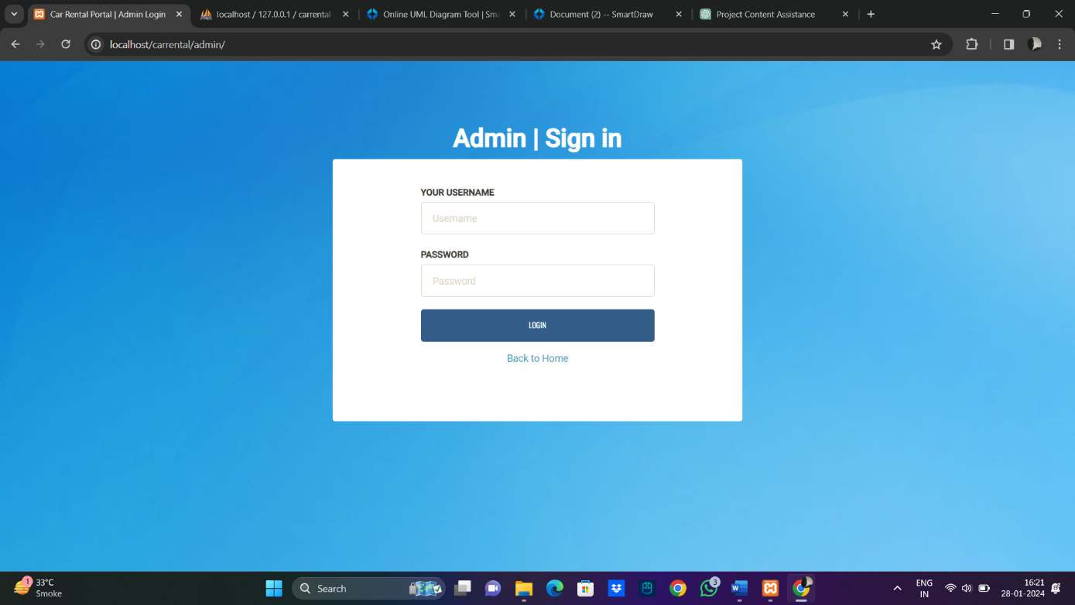

Figure 12 Admin Login

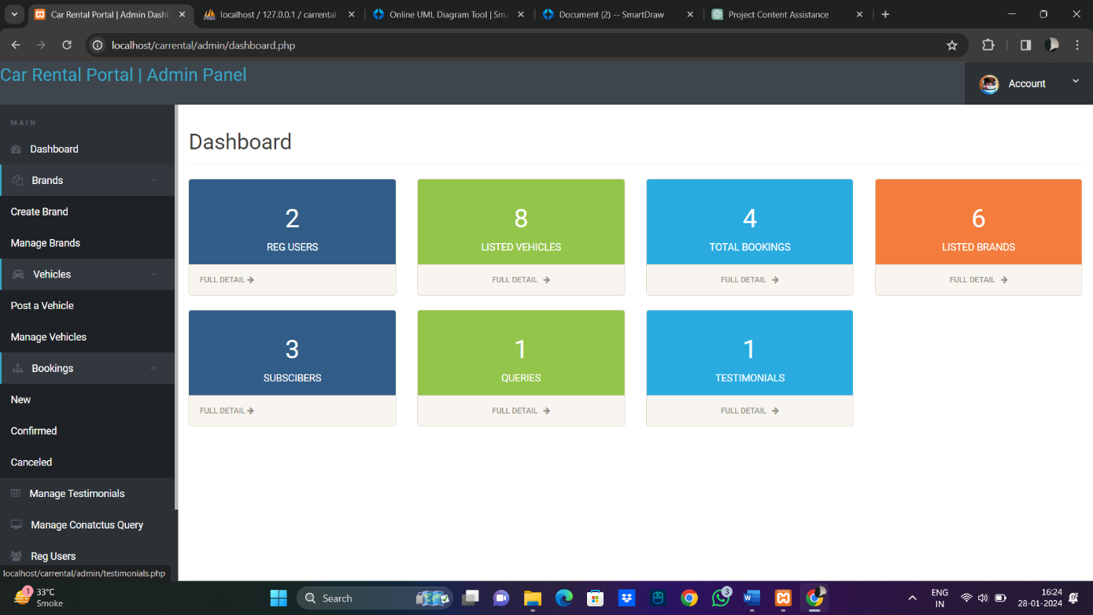

Figure 13 Admin DashBoard

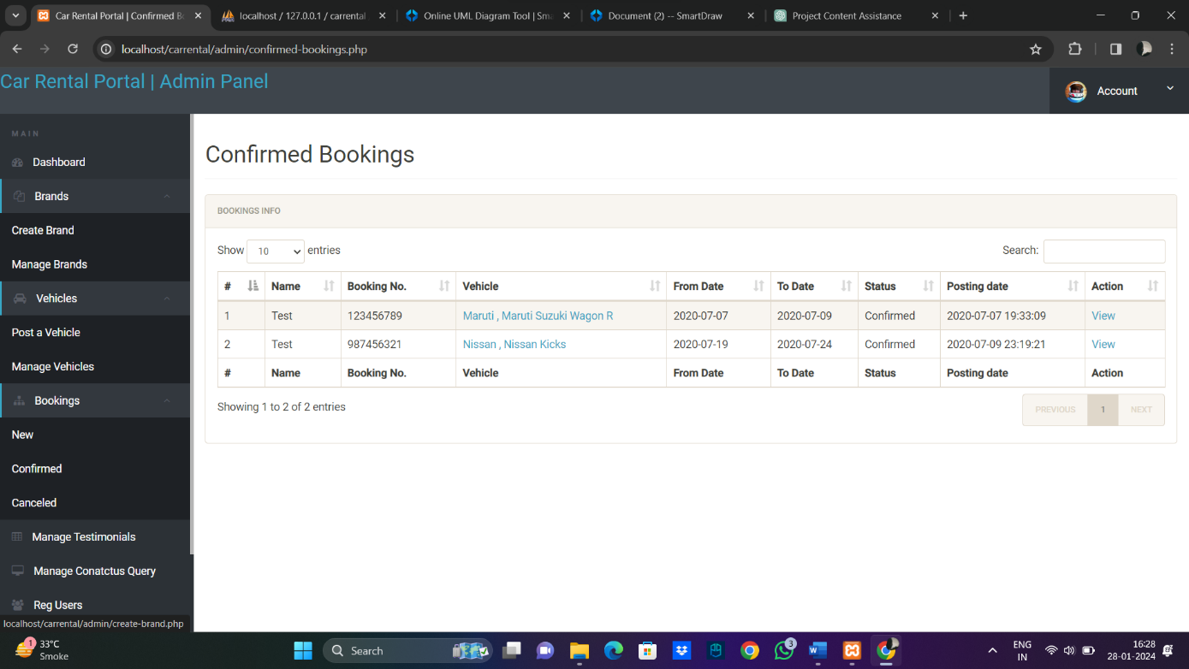

Figure 14 Manage Bookings

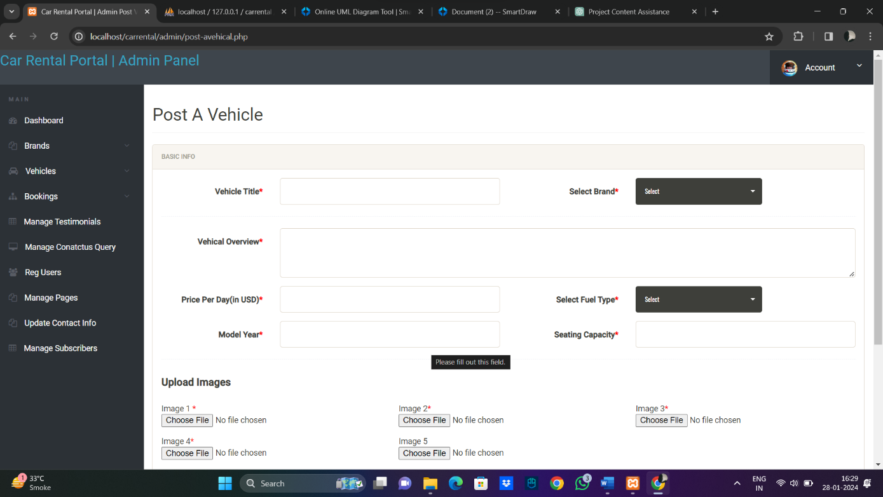

Figure 15 Post A Vehicle Section

# 7. Testing

During the testing phase, the Car Rental Portal underwent meticulous manual testing. The test plan and key test cases for crucial modules are detailed below:

## 7.1 Test Plan

* **Plan Identifier:** 01_Test_Plan
* **Test Items:**
  + Software Testing
  + Hardware Testing
  + Network Connection
  + Database Management
  + Interface
* **Features to be Tested:**
  + Software Testing
  + Hardware Testing
  + Network Connection
  + Database Management
  + User Registration
  + Car Booking
  + Admin Dashboard
  + Vehicle Brands Management
  + Vehicle Management
  + Testimonials Management
  + Contact Us Queries Management
  + Subscribers Management
* **Features Not to be Tested:**
  + Guest User Functionality
  + General Information Display
  + Guest Inquiry
* **Test Approach:**
  + Unit Testing: Validate individual components.
  + Integration Testing: Validate interfaces and data exchange.
  + System Testing: Test end-to-end functional flows.
  + Performance Testing: Peak loads, stress testing.
  + Security Testing: Authentication, access control.
  + Acceptance Testing: Ensure the system meets business needs.
* **Test Deliverables:**
  + Test plans for each level of testing
  + Test cases and test scripts
  + Test data for all scenarios
  + Defect reports
  + Test summary report
* **Testing Tasks:**
  + Prepare unit test cases
  + Review integration test plan
  + Execute system test cases
  + Run performance tests
* **Environmental Requirements:**
  + Software
  + Hardware
  + Network Connectivity
* **Responsibility:**
  + Execute system tests
  + Perform integration testing
  + Create test data
  + Set up test environment
* **Schedule of Test:**
  + Test Planning
  + Test Environment Setup
  + Testing Execution
  + Testing Completed
* **Approval:**
  + All test plans executed successfully and approved on 13/12/2023

## 7.2 Test Cases

7.2.1 Module: User Registration

|  |  |  |  |  |  |  |
| --- | --- | --- | --- | --- | --- | --- |
| Test ID | Test Title | Description | Steps | Expected Result | Actual Result | Result |
| 01 | Registration | User can register through the registration page | Click on registration page | Registration page displays | Registration page displays | Pass |
| 02 | Email ID | User enters their email ID in the registration page | Enter email ID | Email entered successfully | Email entered successfully | Pass |
| 03 | Password | User sets their password (minimum 6 characters) | Enter password | Password entered successfully | Password entered successfully | Pass |
| 04 | Register Button | User is able to complete registration | Click on register button | User gets registered | User gets registered | Pass |

7.2.2 Module: Car Booking

|  |  |  |  |  |  |  |
| --- | --- | --- | --- | --- | --- | --- |
| Test ID | Test Title | Description | Steps | Expected Result | Actual Result | Result |
| 05 | Car Selection | User selects a car for booking | Click on available car | Car selected successfully | Car selected successfully | Pass |
| 06 | Booking Details | User enters booking details | Enter booking information | Booking information entered successfully | Booking information entered successfully | Pass |
| 07 | Confirm Booking | User confirms the booking | Click on confirm booking | Booking confirmed successfully | Booking confirmed successfully | Pass |
| 08 | View History | User views booking history | Click on booking history | Booking history displayed | Booking history displayed | Pass |

7.2.3 Module: Admin Dashboard

|  |  |  |  |  |  |  |
| --- | --- | --- | --- | --- | --- | --- |
| Test ID | Test Title | Description | Steps | Expected Result | Actual Result | Result |
| 09 | Vehicle Brands Management | Admin manages vehicle brands | Click on manage brands | Brands displayed for editing/deleting | Brands displayed for editing/deleting | Pass |
| 10 | Vehicle Management | Admin manages vehicles | Click on manage vehicles | Vehicles displayed for editing/deleting | Vehicles displayed for editing/deleting | Pass |
| 11 | Testimonials Management | Admin manages testimonials | Click on manage testimonials | Testimonials displayed for editing/deleting | Testimonials displayed for editing/deleting | Pass |
| 12 | Contact Us Queries Management | Admin manages queries | Click on manage queries | Queries displayed for editing/deleting | Queries displayed for editing/deleting | Pass |

7.2.4 Module: Subscribers Management

|  |  |  |  |  |  |  |
| --- | --- | --- | --- | --- | --- | --- |
| Test ID | Test Title | Description | Steps | Expected Result | Actual Result | Result |
| 13 | View Subscribers | Admin views subscribers | Click on view subscribers | Subscribers list displayed | Subscribers list displayed | Pass |

# 8. Conclusion

Conclusively, the Car Rental Portal's successful implementation relies on a meticulous execution of specified requirements. By integrating key features and following best practices, the project aims to deliver substantial value to users in the car rental business. The test plan provides a robust framework to ensure the reliability and quality of the system. Rigorous testing, continuous improvement, and adaptability to changing requirements contribute to the project's overall success. Regular reviews and updates to the test plan ensure the testing process remains effective throughout the development lifecycle.